# JS Advanced: Exam Preparation 2

**Link to contest**: <https://judge.softuni.org/Contests/3876>

**Problem 1. Ski Lift**

**Environment Specifics**

Please be aware that every JS environment may **behave differently** when executing code. Certain things that work in the browser are not supported in **Node.js**, which is the environment used by **Judge**.

The following actions are **NOT** supported:

* **.forEach()** with **NodeList** (returned by **querySelector()** and **querySelectorAll()**)
* **.forEach()** with **HTMLCollection** (returned by **getElementsByClassName()** and **element.children**)
* Using the **spread-operator** (**...**) to convert a **NodeList** into an array
* **append()** in Judge (use only **appendChild()**)
* **prepend()**
* **replaceWith()**
* **replaceAll()**
* **closest()**
* **replaceChildren()**
* Always turn the collection into a **JS array** (forEach, forOf, et.)

If you want to perform these operations, you may use **Array.from()** to first convert the collection into an array.

**Use the provided skeleton to solve this problem.**

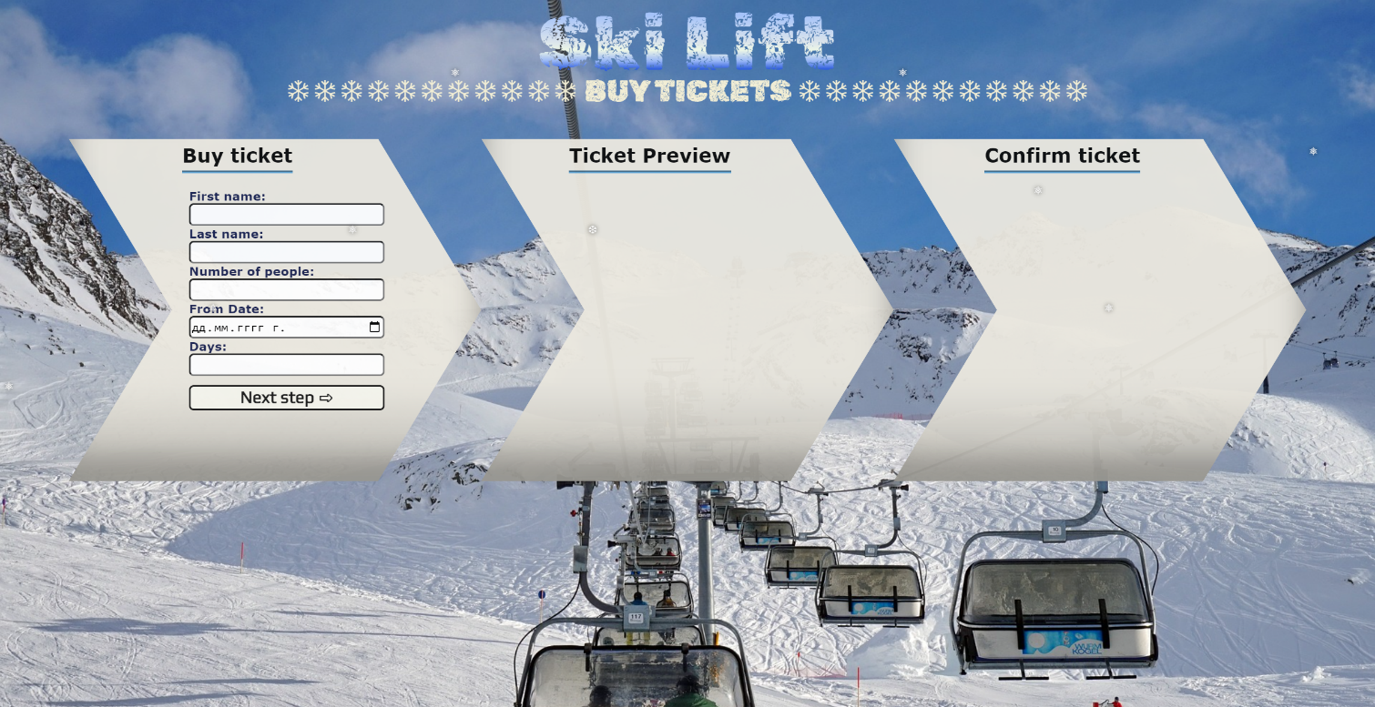**Write the missing functionality** of this user interface. The functionality is divided in the following steps:

**Your Task**

**Write the missing JavaScript code** to make the **Ski Lift** work as expected:

All fields **(First Name, Last Name, Number of people, From date** and **Number of days)** are **filled with the correct input.**

* **First Name, Last Name, Number of people, From date** and **Number of days** are **non**-**empty** **strings.** If any of them is empty, the program should not do anything.

1. **Getting the information from the form**

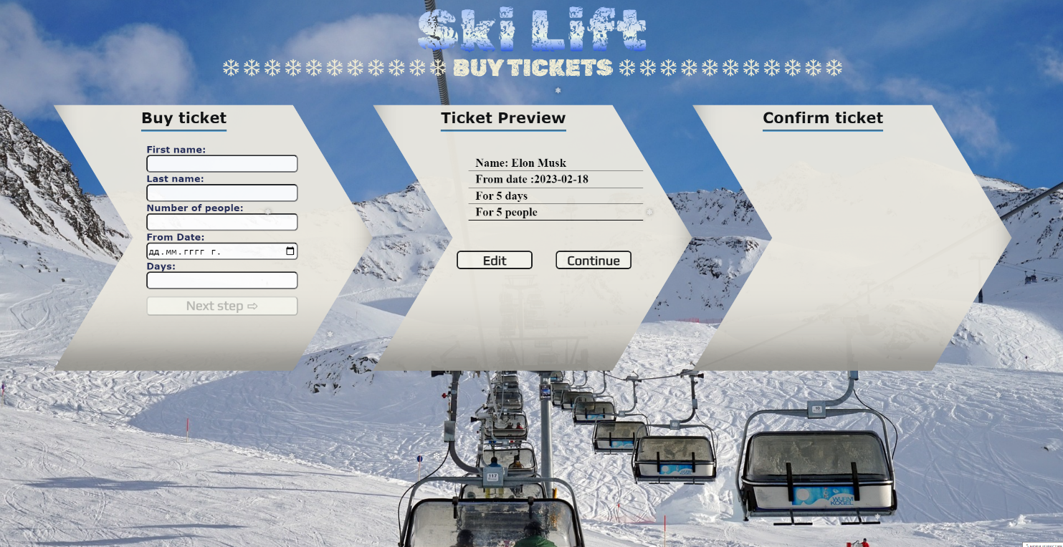

* On clicking the **["Next step"]** button the information from the input fields is listed in the **"info-ticket"** section. For the input fields a **list item** is **added** to the **"** **ticket-info-list"** unordered list.
* The text format and order for the list item should be the same as on the picture below.
* When the button is clicked, the input fields must be cleared and the **["Next step"]** button must be **disabled**. At the same time the **"Edit"** and the **"Continue"** buttons must be **enabled**.

The HTML structure looks like this:

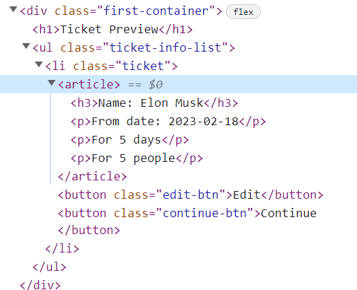

## 2.Edit Information

* **When the "Edit" button is clicked, all of the information is loaded in the input fields from step 1 and the ["Next step"] button is enabled again.**

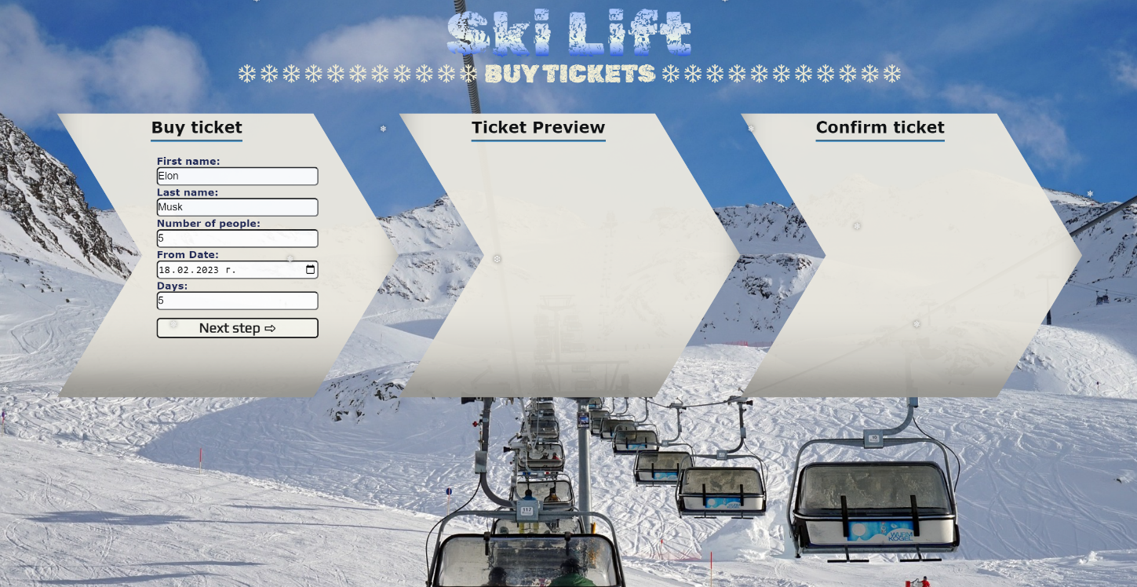

* **The list item must be removed from the " ticket-info-list" and all of the information must go back to the input fields again.**

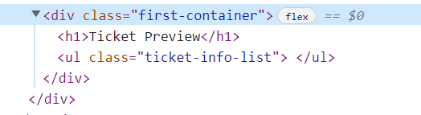

## 3.Continue

* **When the "Continue" button is clicked,** **the information from "ticket-info-list"** unordered list must be transferred to **"confirm-ticket"** in the **same** HTML structure**. For you, this means removing everything inside of the ul with class "ticket-content " and adding in "confirm-ticket"**, **the list item with same information and class "ticket-info-list" , delete "Edit"** and **"Continue"** buttons and **add** new buttons **"Confirm"** and **"Cancel"** with **class "confirm-btn"** and **"cancel-btn"** .

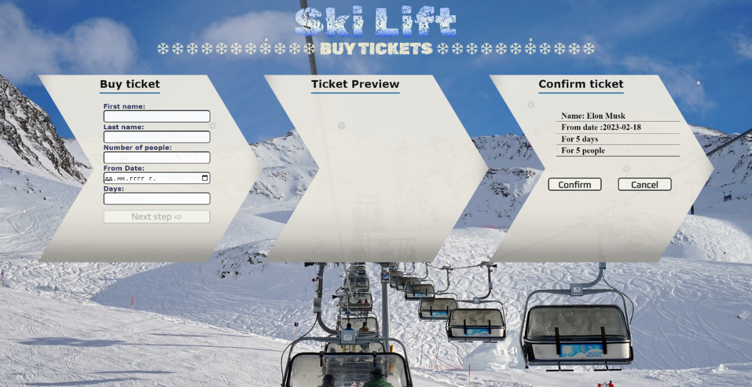

* **This is HTML** structure **of "confirm-ticket"** unordered list**:**

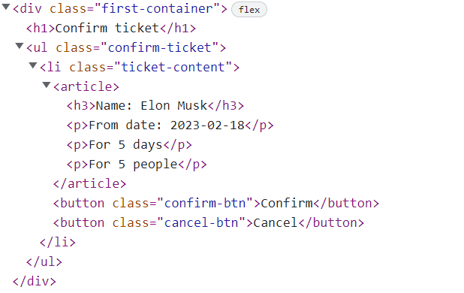

## 4.Cancel

* **When the "Cancel" button is clicked,** **the list item must be removed, from the "confirm-ticket", the ["Next step"] button is enabled again.**

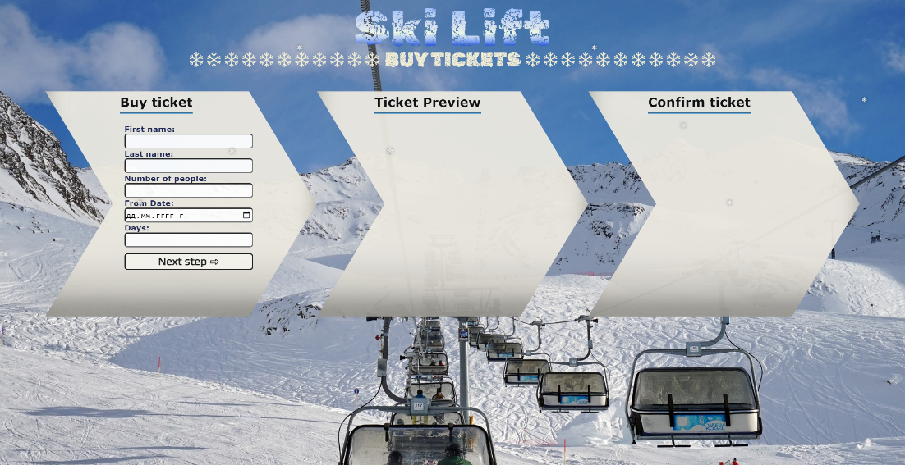

* **When the "Confirm" button is clicked,** **the <div> element with id="main" must be removed, from the body** andyoumust **add <h1>** element with id=**"thank-you"** and **text "Thank you, have a nice day! "** and **<button>** with id=**"back-btn"** and **text "Back ".**



The HTML structure looks like this:

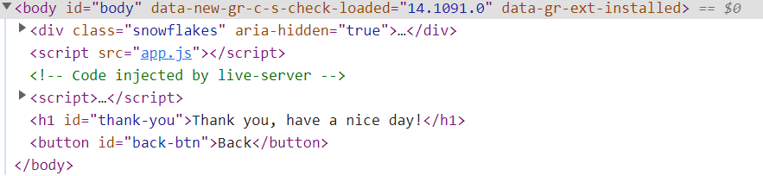

* On clicking the **["Back"]** button you must **reload** the page.

# Problem 2. Wine Selection

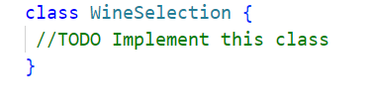

Write a class **WineSelection**, which implements the following functionality:

**Functionality**

**Constructor**

Should have these **3** properties:

* **space –** Number
* **wines –** Array (empty)
* **bill** - number

**At the initialization of the WineSelection class,** the **constructor** accepts the **space.**

**Hint:** You can add more properties to help you finish the task.

**reserveABottle (wineName, wineType, price)**

The **wineName** and **wineType** are of type **string** and **price** is type **number**.

* If there's **not enough space in the cellar** for the bottle, **throw an Error**:

**"Not enough space in the cellar."**

* Otherwise, this function should add the wine, with the properties: **wineName**, **wineType**, **price**, **paid**: **default false**, to the wines array and **return**:

**"You reserved a bottle of {wineName} {wineType} wine."**

**// СТИГНАЛИ СМЕ ДО ТУК, ПЪРВИЯ МЕТОД РАБОТИ БЕЗ ПРОБЛЕМ.**

**payWineBottle( wineName, price )**

The **wineName** is type **string** and **price** is type **number**.

* If the wine is not found, **throw an Error**:

**"{wineName} is not in the cellar."**

* If the wine has already paid, **throw an Error**:

**"{wineName} has already been paid."**

* Otherwise, this function set **paid** to **true** on the found wine, add **price** of the bottleto **bill** and **return**:

**"You bought a {wineName} for a {price}$."**

**// завършено, изпробвано с 1 и трети вход.**

**openBottle(wineName)**

* If the wine is **not found**, throw **an Error:**

**"The wine, you're looking for, is not found."**

* If the wine **hasn't paid**, throw **an Error**:

**"{wineName} need to be paid before open the bottle."**

* Otherwise, this function should **remove** the wine from the array and **return**:

**"You drank a bottle of {wineName}."**

**изпровано**

**cellarRevision(wineType)**

This **method** can be called **with one parameter** or **without** any.

If **no** parameter is provided, the method should **return** the full information of the cellar

* At the first line:

**"You have space for { emptySlots } bottles more."**

* At the second line:

**"You paid {bill}$ for the wine."**

* On the next lines, display information about each wine, **sorted alphabetically ascending**, by their **wineName**:

**"{wineName} > {wineType} - {Has Paid / Not Paid}."**

If the method is called with a parameter for **wineType**:

* **Return** only the information about the wine from the given **wineType**:

**"{wineName} > {wineType} - {Has Paid / Not Paid}."**

* If there is **no such wine type** found, **throw an Error**:

**"There is no {wineType} in the cellar."**

## Example

|  |
| --- |
| **Input 1** |
| const selection = new WineSelection(2)  console.log(selection.reserveABottle('Sauvignon Blanc Marlborough', 'White', 50));  console.log(selection.reserveABottle('Cabernet Sauvignon Napa Valley', 'Red', 120));  console.log(selection.reserveABottle('Bodegas Godelia Mencía', 'Rose', 144)); |
| **Output 1** |
| You reserved a bottle of Sauvignon Blanc Marlborough White wine.  You reserved a bottle of Cabernet Sauvignon Napa Valley Red wine.  Uncaught Error Error: Not enough space in the cellar. |

|  |
| --- |
| **Input 2** |
| const selection = new WineSelection(2)  selection.reserveABottle('Sauvignon Blanc Marlborough', 'White',50);  console.log(selection.payWineBottle('Sauvignon Blanc Marlborough', 120));  console.log(selection.payWineBottle('Bodegas Godelia Mencía', 144)); |

|  |
| --- |
| **Output 2** |
| You bought a Sauvignon Blanc Marlborough for a 120$.  Uncaught Error Error: Bodegas Godelia Mencía is not in the cellar. |

|  |
| --- |
| **Input 3** |
| const selection = new WineSelection(2)  selection.reserveABottle('Sauvignon Blanc Marlborough', 'White', 50);  selection.reserveABottle('Cabernet Sauvignon Napa Valley', 'Red', 120);  selection.payWineBottle('Sauvignon Blanc Marlborough', 50);  console.log(selection.openBottle('Sauvignon Blanc Marlborough'));  console.log(selection.openBottle('Cabernet Sauvignon Napa Valley')); |
| **Output 3** |
| You drank a bottle of Sauvignon Blanc Marlborough.  Uncaught Error Error: Cabernet Sauvignon Napa Valley need to be paid before open the bottle. |

|  |
| --- |
| **Input 4** |
| const selection = new WineSelection(2)  console.log(selection.reserveABottle('Bodegas Godelia Mencía', 'Rose', 144));  console.log(selection.cellarRevision('Rose')); |

|  |
| --- |
| **Output 4** |
| You reserved a bottle of Bodegas Godelia Mencía Rose wine.  Bodegas Godelia Mencía > Rose - Not Paid. |

|  |
| --- |
| **Input 5** |
| const selection = new WineSelection(5)  selection.reserveABottle('Bodegas Godelia Mencía', 'Rose', 144);  selection.payWineBottle('Bodegas Godelia Mencía', 144);  selection.reserveABottle('Sauvignon Blanc Marlborough', 'White', 50);  selection.reserveABottle('Cabernet Sauvignon Napa Valley', 'Red', 120);  console.log(selection.cellarRevision()); |

|  |
| --- |
| **Output 5** |
| You have space for 2 bottles more.  You paid 144$ for the wine.  Bodegas Godelia Mencía > Rose - Has Paid.  Cabernet Sauvignon Napa Valley > Red - Not Paid.  Sauvignon Blanc Marlborough > White - Not Paid. |

# Problem 3. Unit Testing

**Your Task**

Using **Mocha** and **Chai** write **JS Unit Tests** to test a variable named **findNewApartment**, which represents an object. You may use the following code as a template:

|  |
| --- |
| describe(**"*Tests* …"**, **function**() {  describe(**"*TODO* …"**, **function**() {  ***it***(**"*TODO …*"**, **function**() {  *//* ***TODO:*** …  });  });  *//* ***TODO:*** …  }); |

The object that should have the following functionality:

* **isGoodLocation (city, nearPublicTransportation) -** A function that accepts two parameters: **string** and **boolean**.
* If the value of the string **city** is different than a "**Sofia**", "**Plovdiv**" or "**Varna**"

return :

**"This location is not suitable for you."**

* If the value of the boolean **nearPublicTransportation** is **false**

return :

**"There is no public transport in area."**

* Otherwise, if the above conditions are not met, **return** the following message:
* **"You can go on home tour!"**
* You need to validate the input, if the **city** and **nearPublicTransportation** are not a **string** and **boolean**, **throw** an error: "**Invalid input!**".
* **isLargeEnough (apartments, minimalSquareMeters) -** A function that accepts an **array** and **number**.
  + The **apartments** array will store the area of the apartment in square meters ([40, 50, 60…])
  + You must **add** the area of apartment in **resultArr** if is **equal** or **bigger** than **minimalSquareMeters**.
* Finally, **return** the changed array of apartments.
  + There is a need for validation for the input, an **array** and **number** may not always be valid. In case of submitted **invalid** parameters, **throw** an error "**Invalid input!**":
    - If passed **apartments** parameteris not an array.
    - If **apartments** is empty **array.**
    - If the **minimalSquareMeters** is not a number.
* **isItAffordable (price, budget) -** A function that accepts two parameters: **number** and **number**.
* You need to **calculate** if you can afford buying the apartment by **subtracting** the **price** of the apartment from your **budget**.
* If the **result** is lower than **0,** return**:**

**"You don't have enough money for this house!"**

* Otherwise, if the above conditions are not met, **return** the following message:

**"You can afford this home!"**

* You need to validate the input, if the **price** and **budget** are not a **number** and **price** and **budget** are **less** or **equal** to0**, throw** an error: "**Invalid input!**".

**JS Code**

To ease you in the process, you are provided with an implementation that meets all of the specification requirements for the **findNewApartment** object:

|  |
| --- |
| findApartment.js |
| const findNewApartment = {    isGoodLocation(city, nearPublicTransportation) {      if (typeof city !== "string" || typeof nearPublicTransportation !== "boolean"){          throw new Error("Invalid input!");      }      if (city !== "Sofia" && city !== "Plovdiv" && city !== "Varna") {          return "This location is not suitable for you.";      }else {          if (nearPublicTransportation == true) {              return "You can go on home tour!";          }          else {              return "There is no public transport in area.";          }      }    },    isLargeEnough(apartments, minimalSquareMeters) {      let resultArr = [];      if (!Array.isArray(apartments) || typeof minimalSquareMeters !== "number" || apartments.length == 0) {        throw new Error("Invalid input!");      }      apartments.map((apartment) => {        if (apartment >= minimalSquareMeters) {          resultArr.push(apartment);        }      });      return resultArr.join(', ');    },    isItAffordable(price, budget) {      if (typeof price !== "number" || typeof budget !== "number"       || price <= 0 || budget <= 0) {        throw new Error("Invalid input!");      }      let result = budget - price;      if (result < 0) {        return "You don't have enough money for this house!";      } else {        return "You can afford this home!";      }    },  }; |